import pandas as pd import numpy as np from sklearn.model_selection import train_test_split from sklearn.feature_extraction.text import TfidfVectorizer from sklearn.linear_model import LogisticRegression from sklearn.metrics import accuracy_score, confusion_matrix, roc_curve, roc_auc_score import nltk from nltk.corpus import stopwords from collections import Counter
#libraries for data visualization import matplotlib.pyplot as plt import seaborn as sns %matplotlib inline
df= pd.read_csv("/content/spam.csv",encoding='ISO-8859-1')
0 | ham | Go until jurong point, crazy.. Available only ... | NaN | NaN | NaN
1 | ham | Ok lar... Joking wif u oni... | NaN | NaN | NaN
2 | spam | Free entry in 2 a wkly comp to win FA Cup fina... | NaN | NaN | NaN
3 | ham | U dun say so early hor... U c already then say... | NaN | NaN | NaN
4 | ham | Nah I don't think he goes to usf, he lives aro... | NaN | NaN | NaN
... | ... | ... | ... | ... | ...
5567 | spam | This is the 2nd time we have tried 2 contact u... | NaN | NaN | NaN
5568 | ham | Will Ì_ b going to esplanade fr home? | NaN | NaN | NaN
5569 | ham | Pity, * was in mood for that. So...any th | NaN | NaN | NaN
df
v1
v2
Unnamed:
2
Unnamed:
3
Unnamed:
4
df.info()
<class 'pandas.core.frame.DataFrame'>
RangeIndex: 5572 entries, 0 to 5571 Data columns (total 5 columns):
# Column Non-Null Count Dtype
--- ------ -------------- -----
- v1 5572 non-null object
- v2 5572 non-null object
- Unnamed: 2 50 non-null object
- Unnamed: 3 12 non-null object 4 Unnamed: 4 6 non-null object dtypes: object(5) memory usage: 217.8+ KB
# Downloading the stopwords dataset nltk.download('stopwords')
[nltk_data] Downloading package stopwords to /root/nltk_data...
[nltk_data] Unzipping corpora/stopwords.zip.
True
# Drop unnecessary columns from the DataFrame
columns_to_drop = ["Unnamed: 2", "Unnamed: 3", "Unnamed: 4"] df.drop(columns=columns_to_drop, inplace=True)
df
v1
v2
0
ham
Go until jurong point, crazy.. Available only ...
1 | ham | Ok lar... Joking wif u oni...
2 | spam | Free entry in 2 a wkly comp to win FA Cup fina...
3 | ham | U dun say so early hor... U c already then say...
4 | ham | Nah I don't think he goes to usf, he lives aro...
... | ... | ...
5567 | spam | This is the 2nd time we have tried 2 contact u...
5568 | ham | Will Ì_ b going to esplanade fr home?
5569 | ham | Pity, * was in mood for that. So...any other s...
5570 | ham | The guy did some bitching but I acted like i'd...
5571 | ham | Rofl. Its true to its name
5572 rows × 2 columns
# Rename the columns "v1 and "v2" to new names
new_column_names = {"v1":"Category","v2":"Message"} df.rename(columns = new_column_names,inplace = True)
df[df.duplicated()]
Category
Message
102
ham
As per your request 'Melle Melle (Oru Minnamin...
153 | ham | As per your request 'Melle Melle (Oru Minnamin...
206 | ham | As I entered my cabin my PA said, '' Happy B'd...
222 | ham | Sorry, I'll call later
325 | ham | No calls..messages..missed calls
... | ... | ...
5524 | spam | You are awarded a SiPix Digital Camera! call 0...
5535 | ham | I know you are thinkin malaria. But relax, chi...
5539 | ham | Just sleeping..and surfing
5553 | ham | Hahaha..use your brain dear
5558 | ham | Sorry, I'll call later
403 rows × 2 columns
#Drop duplicated values df=df.drop_duplicates() df
Category
Message
0
ham
Go until jurong point, crazy.. Available only ...
1
ham
Ok lar... Joking wif u oni...
2
spam
Free entry in 2 a wkly comp to win FA Cup fina...
3
ham
U dun say so early hor... U c already then say...
4
ham
Nah I don't think he goes to usf, he lives aro...
...
...
...
5567
spam
This is the 2nd time we have tried 2 contact u...
5568
ham
Will Ì_ b going to esplanade fr home?
5569
ham
Pity, * was in mood for that. So...any other s...
df.info()
<
class 'pandas.core.frame.DataFrame'
>
Int64Index: 5169 entries, 0 to 5571
Data columns (total 2 columns):
# Column Non-Null Count Dtype
------ -------------- -----
---
0 Category 5169 non-null object
1 Message 5169 non-null object
dtypes: object(2)
memory usage: 121.1+ KB
df.describe()
5570 ham The guy did some bitching but I acted like i'd... 5571 Categoryham Rofl. Its true to its nameMessage
5169count rows × 2 columns5169 5169
unique | 2 | 5169
top | ham | Go until jurong point, crazy.. Available only ...
freq | 4516 | 1
df.shape
(5169, 2)
df['Category'].value_counts()
ham 4516 spam 653 Name: Category, dtype: int64
sns.countplot(data=df, x='Category') plt.xlabel('Category') plt.ylabel('count') plt.title('Distribution of mails') plt.show()
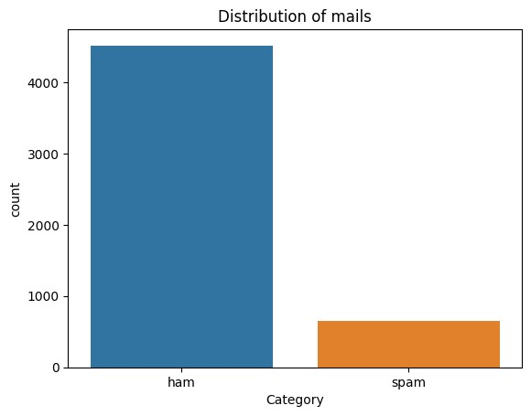
# Convert the "Category" column values to numerical representation (0 for "spam" and 1 for "ham")
df.loc[df["Category"] == "spam", "Category"] = 0 df.loc[df["Category"] == "ham", "Category"] = 1 df.head()
<ipython-input-20-542b71d40cac>:3: SettingWithCopyWarning:
A value is trying to be set on a copy of a slice from a DataFrame
See the caveats in the documentation: https://pandas.pydata.org/pandas-docs/stable/user_guide/indexing.html#returning-a-vie df.loc[df["Category"] == "spam", "Category"] = 0
<ipython-input-20-542b71d40cac>:4: SettingWithCopyWarning:
A value is trying to be set on a copy of a slice from a DataFrame
See the caveats in the documentation: https://pandas.pydata.org/pandas-docs/stable/user_guide/indexing.html#returning-a-vie df.loc[df["Category"] == "ham", "Category"] = 1
Category
Message
0
1
Go until jurong point, crazy.. Available only ...
- 1 Ok lar... Joking wif u oni...
- 0 Free entry in 2 a wkly comp to win FA Cup fina...
- 1 U dun say so early hor... U c already then say... 4 1 Nah I don't think he goes to usf, he lives aro...
# Separate the feature (X) and target (Y) data
- = df["Message"]
- = df["Category"]
X
  - Go until jurong point, crazy.. Available only ...
  - Ok lar... Joking wif u oni...
  - Free entry in 2 a wkly comp to win FA Cup fina...
  - U dun say so early hor... U c already then say...
  - Nah I don't think he goes to usf, he lives aro... ... 5567 This is the 2nd time we have tried 2 contact u...
  - Will Ì_ b going to esplanade fr home?
  - Pity, * was in mood for that. So...any other s...
  - The guy did some bitching but I acted like i'd...
  - Rofl. Its true to its name
Name: Message, Length: 5169, dtype: object
Y
  - 1
  - 1
  - 0
  - 1
  - 1 .. 5567 0
  - 1
  - 1
  - 1
  - 1
Name: Category, Length: 5169, dtype: object
# Split the data into training and testing sets
X_train, X_test, Y_train, Y_test = train_test_split(X, Y, test_size = 0.2, random_state = 42)
print(X.shape) print(X_train.shape) print(X_test.shape)
(5169,)
(4135,)
(1034,)
# Create a TF-IDF vectorizer to convert text messages into numerical features feature_extraction = TfidfVectorizer(min_df=1, stop_words="english", lowercase=True) # Convert the training and testing text messages into numerical features using TF-IDF
X_train_features = feature_extraction.fit_transform(X_train)
X_test_features = feature_extraction.transform(X_test)
# Convert the target values into 0 and 1
Y_train = Y_train.astype(int) Y_test = Y_test.astype(int)
print(X_train)
2228 Those were my exact intentions 5529 What about this one then.
2149 Waaaat?? Lololo ok next time then!
5058 Free video camera phones with Half Price line ...
5051 Tick, tick, tick .... Where are you ? I could ...
...
4740 Many more happy returns of the day. I wish you...
474 Nice line said by a broken heart- Plz don't cu...
3266 Ok then i come n pick u at engin?
4016 Eek that's a lot of time especially since Amer...
879 U have a Secret Admirer who is looking 2 make ...
Name: Message, Length: 4135, dtype: object
print(X_train_features)
(0, 3545) | 0.7455593142248959
(0, 2588) | 0.6664392762829205
(2, 6589) | 0.3136674984299076
(2, 4696) | 0.29654379102529516
(2, 4002) | 0.6378379419700079
(2, 6999) | 0.6378379419700079
(3, 564) | 0.2785767488573773
(3, 1534) | 0.23384958966251285
(3, 52) | 0.26549489341098675
(3, 4344) | 0.22076773421612225
(3, 6770) | 0.2300494583671639
(3, 251) | 0.19582167067522926
(3, 4299) | 0.18532229917229942
(3, 4630) | 0.26549489341098675
(3, 1997) | 0.26549489341098675
(3, 516) | 0.19460402332334106
(3, 4419) | 0.2562131692599451
(3, 271) | 0.23384958966251285
(3, 5450) | 0.2300494583671639
(3, 3941) | 0.18912243046764834
(3, 5171) | 0.20953002785296104
(3, 3168) | 0.19120469004402674
(3, 4954) | 0.23384958966251285
(3, 1553) | 0.20428654549041733
(3, 6938)  : : | 0.19708708091575408
(4132, 1825) | 0.3605065932469792
(4132, 4696) | 0.3418197199207224
(4133, 5893) | 0.376872105216547
(4133, 4973) | 0.36369662422743665
(4133, 2451) | 0.376872105216547
(4133, 901) | 0.36369662422743665
(4133, 4029) | 0.27296922168195425
(4133, 4303) | 0.2797666732547047
(4133, 3930) | 0.19090886726821316
(4133, 2550) | 0.326557029270423
(4133, 4007) | 0.2670514851432264
(4133, 6192) | 0.21536918062740018
(4133, 6589) | 0.19446518344396782
(4134, 45) | 0.36133141627364085
(4134, 6198) | 0.34436343393010593
(4134, 216) | 0.34436343393010593
(4134, 6543) | 0.29397934692144273
(4134, 5512) | 0.31535647652238075
(4134, 799) | 0.31535647652238075
(4134, 5715) | 0.3033175014581906
(4134, 6069) | 0.2508916342134232
(4134, 4013) | 0.26098383065689107
(4134, 1895) | 0.2301166472830892
(4134, 4139) | 0.20748487401135496
(4134, 6867) | 0.16697204675649222
# Create a logistic regression model and train it on the training data
model = LogisticRegression() model.fit(X_train_features, Y_train)
▾LogisticRegression
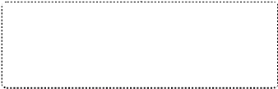
LogisticRegression()
# Make predictions on the training data and calculate the accuracy
prediction_on_training_data = model.predict(X_train_features) accuracy_on_training_data = accuracy_score(Y_train, prediction_on_training_data)
print("Accuracy on training data:",accuracy_on_training_data)
# Make predictions on the test data and calculate the accuracy
prediction_on_test_data = model.predict(X_test_features) accuracy_on_test_data = accuracy_score(Y_test,prediction_on_test_data)
print("Accuracy on test data:",accuracy_on_test_data)
Accuracy on test data: 0.9642166344294004
# Test the model with some custom email messages
input_mail = ["Congratulations! You've won a free vacation to an exotic island. Just click on the link below to claim your prize."] input_data_features = feature_extraction.transform(input_mail) prediction = model.predict(input_data_features)
if (prediction)[0] == 1: print("Ham Mail") else: print("Spam Mail")
Spam Mail
input_mail = ["This is a friendly reminder about our meeting scheduled for tomorrow at 10:00 AM in the conference room. Please make sure to p input_data_features = feature_extraction.transform(input_mail) prediction = model.predict(input_data_features)
if (prediction)[0] == 1: print("Ham Mail") else: print("Spam Mail")
Ham Mail
# Data visualization - Confusion Matrix cm = confusion_matrix(Y_test, prediction_on_test_data)
plt.figure(figsize=(6, 4)) sns.heatmap(cm, annot=True, fmt="d", cmap='Blues', cbar=False) plt.xlabel('Predicted') plt.ylabel('True') plt.title('Confusion Matrix') plt.show()
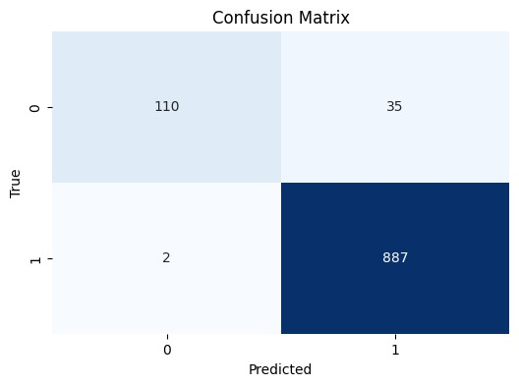
# Data visualization - Top 10 Most Common Words in
Spam Emails
stop_words =
set
(
stopwords.words
(
'english'
))
spam_words =
" "
.join(df[df[
'Category'
]
==
0
][
'Message'
])
.split
()
ham_words =
" "
.join(df[df[
'Category'
]
==
1
][
'Message'
])
.split
()
spam_word_freq = Counter([word.lower()
for
word
in
spam_words
if
word.lower()
not

in
stop_words
and
word.isalpha()])
plt.figure(figsize=(
10
,
6
))
plt.bar(*
zip
(
*spam_word_freq.most_common
(
10
))
, color
=
'g'
)
plt.xlabel(
'Words'
)
plt.ylabel(
'Frequency'
)
plt.title('Top 10 Most Common Words in Spam Emails') plt.xticks(rotation=45) plt.show()
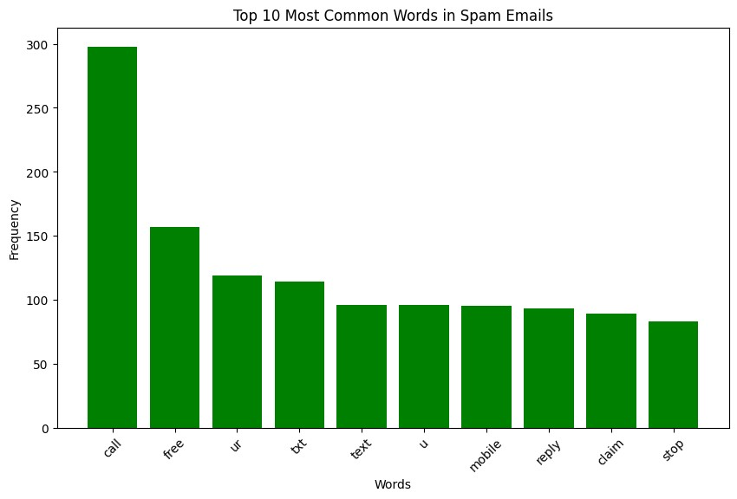
# Data visualization - Top 10 Most Common Words in Ham Emails ham_word_freq = Counter([word.lower() for word in ham_words if word.lower() not in stop_words and word.isalpha()])
plt.figure(figsize=(10, 6)) plt.bar(*zip(*ham_word_freq.most_common(10)), color='maroon') plt.xlabel('Words') plt.ylabel('Frequency') plt.title('Top 10 Most Common Words in Ham Emails') plt.xticks(rotation=45) plt.show()
